USER INTERFACE DESIGN

EXPERIMENT 1: COMPARISION OF UI DESIGN BETWEEN TWO FIGMA CREATION

NAME: JAI SHURIYA REG NO: 240701200

Bad Design:


Good Design:
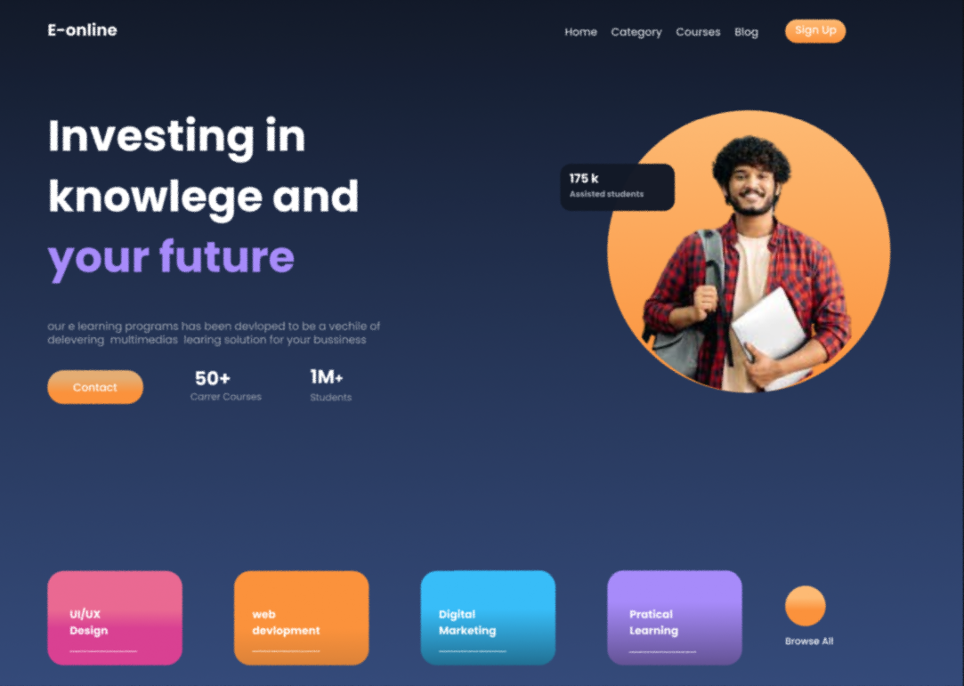

PROTOTYPE LINK:

https://www.figma.com/proto/8nE3D7Ye4cm6stuVrw7OEi?node-id=0-1&t=gyrfbB12h5ZyVw7c-6
https://www.figma.com/design/kPzn1tVyi5z1rQgiQkF0OH/Untitled?m=auto&t=gyrfbB12h5ZyVw7c-6

Comparison Between the Two Websites
The two clothing store websites demonstrate different approaches to user interface design. The bad website lacks structure and clarity, whereas the good website follows proper UI principles to enhance user experience.

BAD WEBSITE (Luna Store)

1. Layout & Structure
- The layout appears cluttered and poorly organized.
- Elements are not properly aligned.
- Sections are not clearly separated, making the interface look crowded.
2. Visual Hierarchy
- Headings, images, and buttons do not stand out.
- Users may find it difficult to identify important information.
- No clear focal point is present.

3. Colour Usage & Contrast
- Too many bright and inconsistent colours are used.
- Poor contrast between text and background reduces readability.
- The colour scheme does not match the clothing theme.

4. Typography
- Multiple fonts are used without consistency.
- Text sizes vary unevenly across the page.
- Some text is difficult to read.

5. Navigation
- Navigation is unclear and confusing.
- Important menu items are not easily visible.
- Users may struggle to move between sections.

6. Content Clarity
- Too much information is displayed in one place.
- Lack of spacing creates visual overload.
- Users cannot scan the content quickly.
GOOD WEBSITE (Luna Store)

1. Layout & Structure
- The website has a clean and well-structured layout.
- Proper spacing improves readability.
- Content is grouped logically (navbar, hero section, categories, products).
2. Visual Hierarchy
- Large headings highlight key messages such as “New Arrivals.”
- Buttons are clearly visible to attract user attention.
- The design guides the user naturally through the page.

3. Colour Usage & Contrast
- A limited and consistent colour palette is used.
- Soft fashion-oriented colours create a premium feel.
- High contrast ensures text is easy to read.
4. Typography
- One or two fonts are used consistently throughout the interface.
- Proper font sizes improve readability.
- The typography enhances the modern fashion aesthetic.

5. Navigation
- The navigation bar is simple and easy to understand.
- Users can quickly access categories like Dresses, Tops, and Bags.
- The user flow is smooth and intuitive.
6. Content Clarity
- Information is presented in a clean and organized manner.
- Adequate whitespace prevents clutter.
- Users can easily scan products and categories.
Key Differences Between Good UI and Bad UI
- Layout: Good UI is structured and spacious, while Bad UI appears cluttered.
- Navigation: Good UI provides clear pathways for users, whereas Bad UI creates confusion.
- Visual Hierarchy: Good UI highlights important elements, while Bad UI lacks emphasis.
- Consistency: Good UI maintains uniform colours, fonts, and spacing, while Bad UI is inconsistent.
- User Experience: Good UI improves usability and engagement, whereas Bad UI leads to frustration.

Conclusion
This experiment highlights the importance of effective user interface design in enhancing user experience. The good website follows essential UI principles such as consistency, hierarchy, spacing, and readability, making it visually appealing and user-friendly. In contrast, the bad website demonstrates how poor design choices can negatively impact usability.

